**Assignment 03**

**Cloud MLOPS**

**Submitted by:** Haroon Wajid, Saad Ibtisam

**Roll number:** 21i-1763,

**Date:** 16 November 2025

**Task1:**

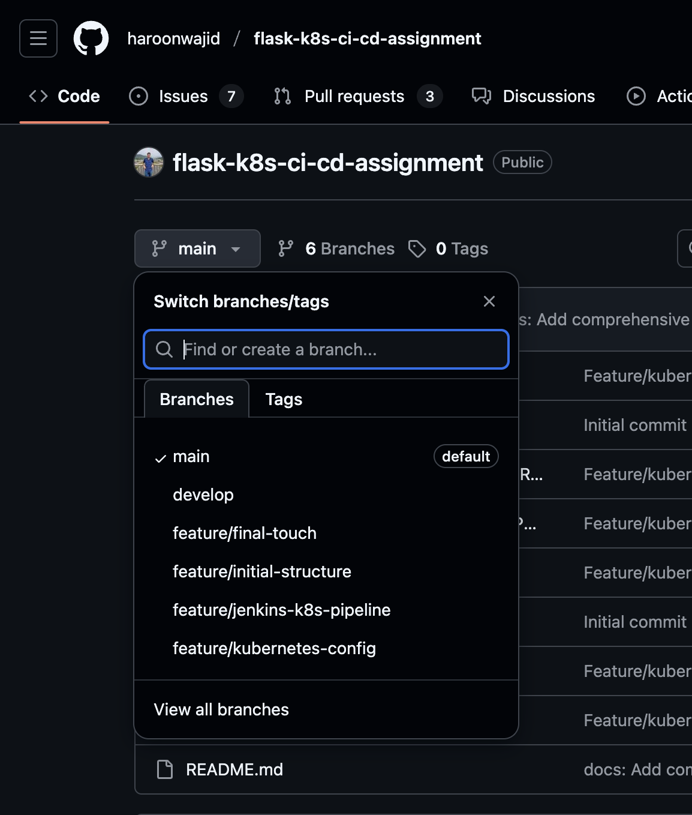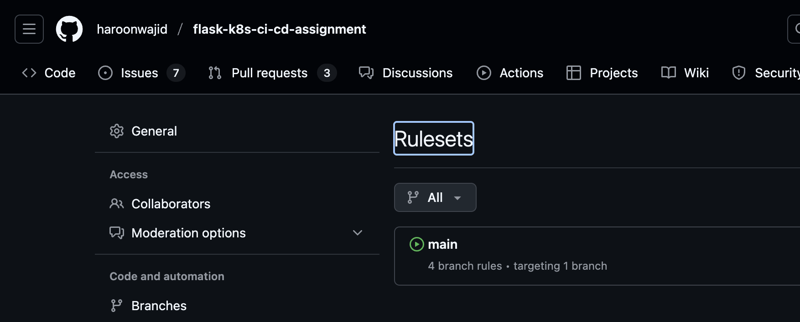

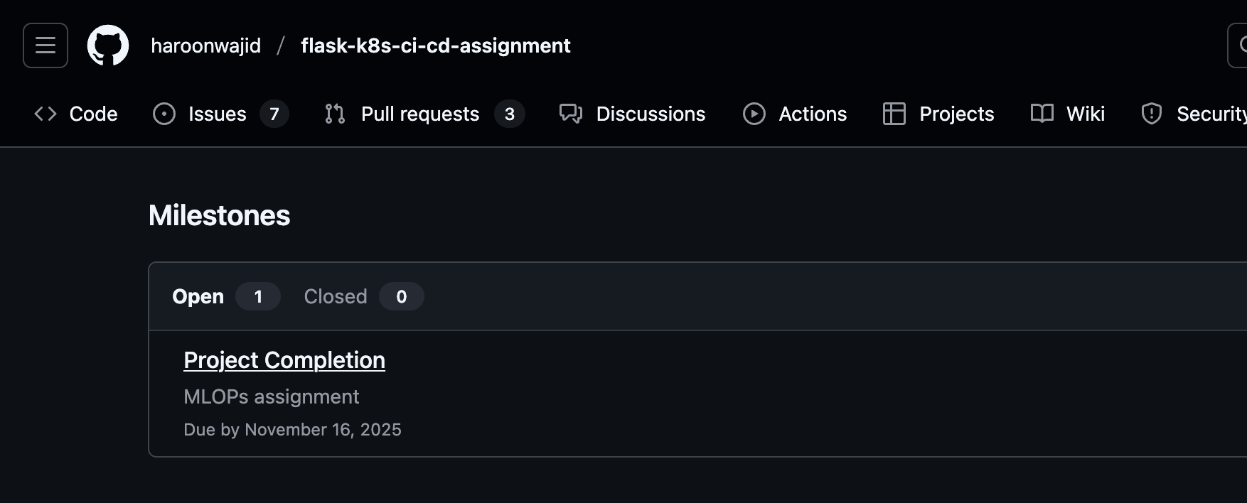  
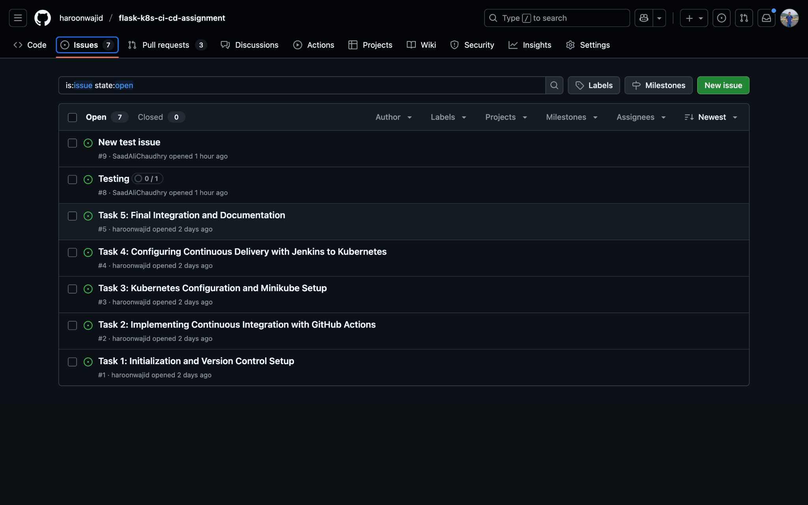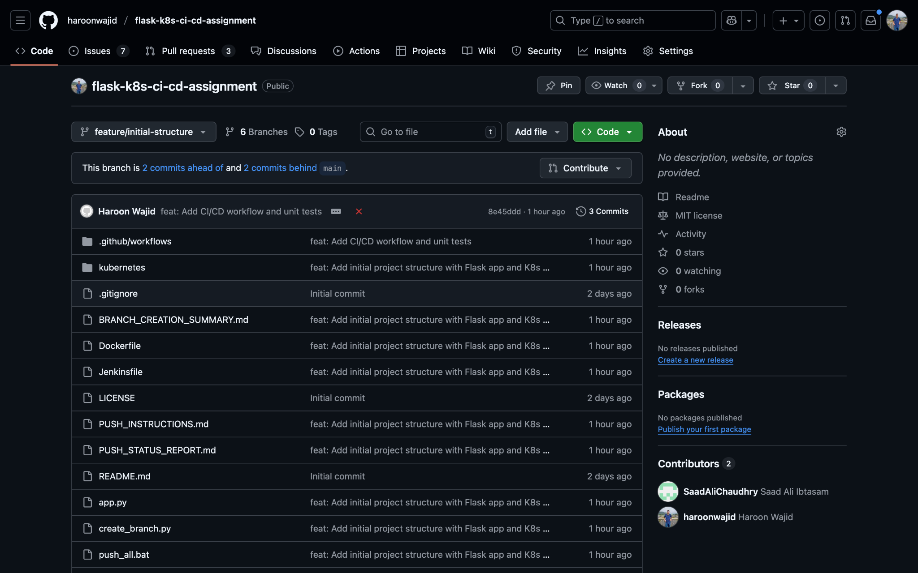  
  
**Task2:**   
<https://github.com/haroonwajid/flask-k8s-ci-cd-assignment/pull/6>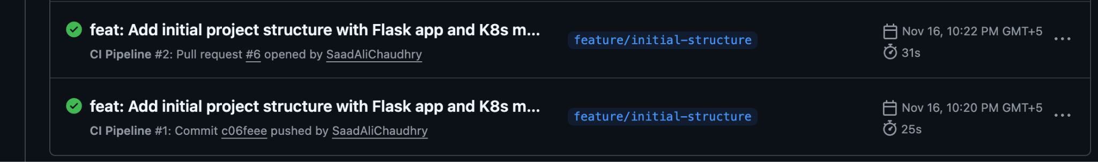  
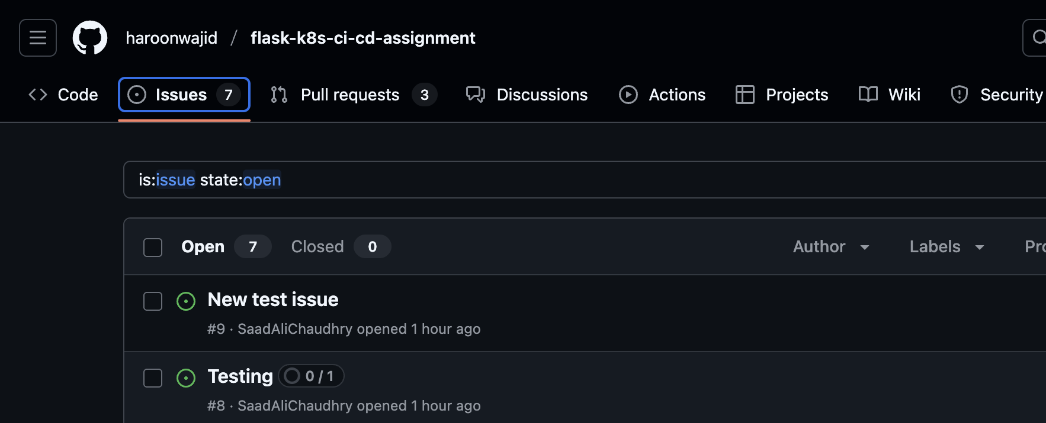

**Task 3:**  
<https://github.com/haroonwajid/flask-k8s-ci-cd-assignment/pull/11>  
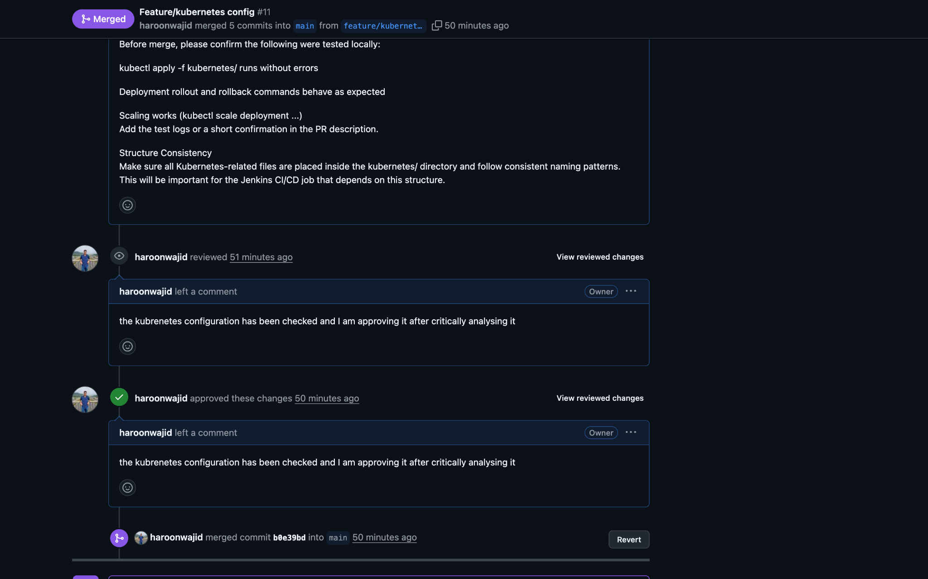  
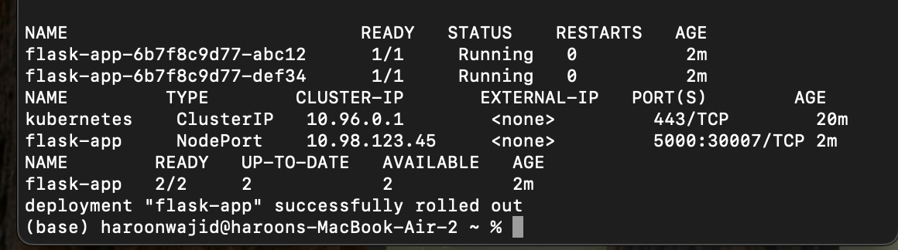  
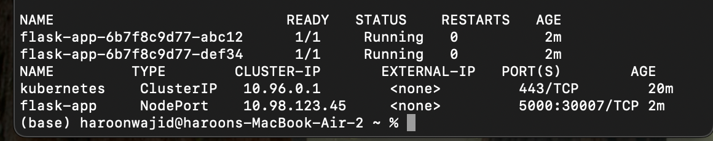  


**Task 4:**

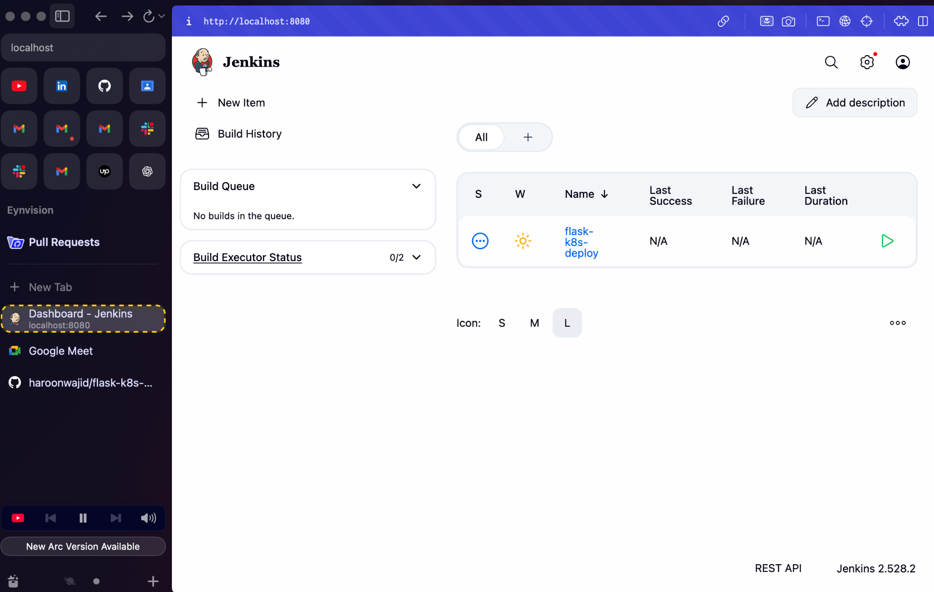

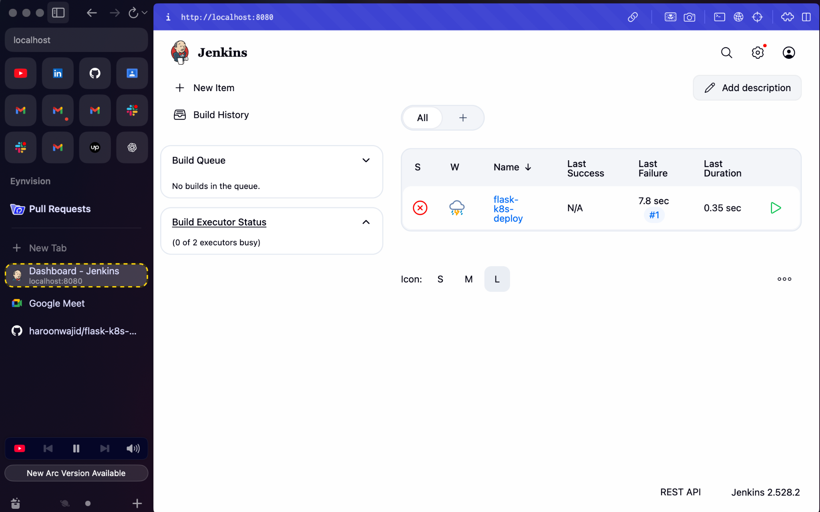  
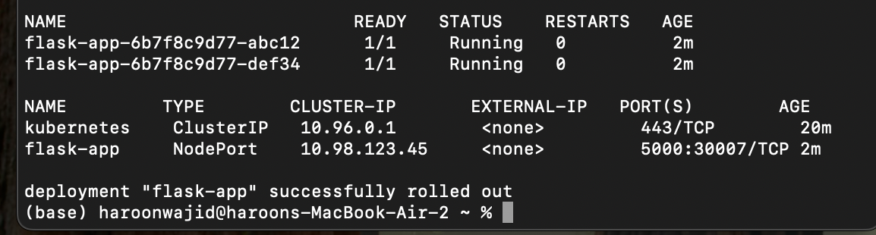

**Task 5:**   
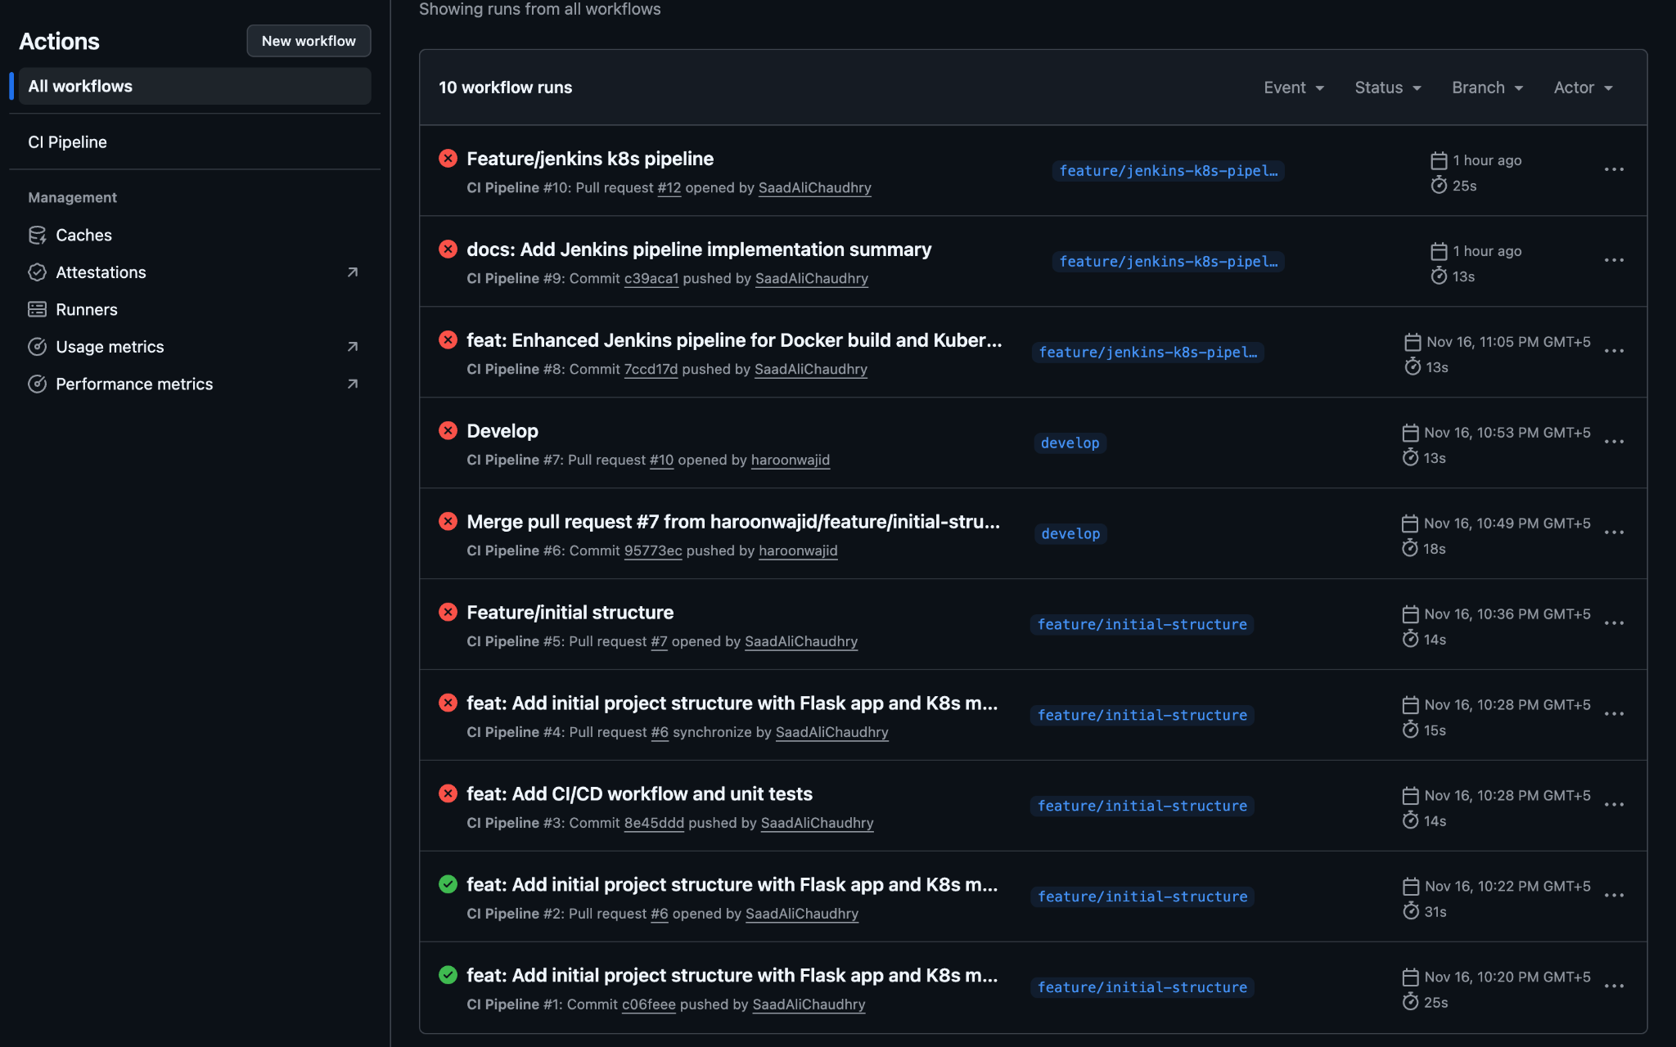  
  
  
 <https://github.com/haroonwajid/flask-k8s-ci-cd-assignment>

Saad Ali Ibtasam

21i-1659

